
Anatomy & Physiology Lesson 6 Exam
Please read these instructions before you begin to answer the questions that follow.
You are welcome to work your answers on this paper examination for your convenience. You will submit your final answers through an uploaded file through our app. When you are satisfied that your answers are correct, use the app to download an instruction file for the corresponding lesson. This will open the lesson, so you are able to add your work for grading. Complete this file upload for grading. Only the answers on the submitted file will be considered for grading.

You have reached the end of Lesson 6 and are ready for your Lesson 6 Examination. After you complete it, log in and submit through the app. Good luck!

Instructions:
Follow the instructions for each question. Show your work in the space provided and write the answer on the line. You will need to show your work on the file submitted to your teacher for grading.

Multiple Choice (worth 2 points each): Enter your selected answer into the blank space provided.

_____1. What is the basic working unit of the kidneys?
  - renal cortex
  - renal medulla
  - nephron
  - hilum

_____2. Which of the following is the name of the lighter-colored, outer part of the kidney?
  - renal cortex
  - renal medulla
  - renal pelvis
  - renal pyramids

_____3. All of the following are true EXCEPT
  - the kidneys are retroperitoneal
  - the ureter is lined with smooth muscle
  - the right kidney is slightly higher than the left kidney
  - blood enters the glomerulus through the afferent arteriole

_____4. True or False: Cortical nephrons are the only nephrons that produce highly concentrated urine.
  - True
  - False

_____5. Where do the renal artery, vein, ureter, and nerve connect to the kidney?
  - renal pelvis
  - fibrous capsule
  - renal pyramid
  - hilum

_____6. Which of the following is the correct order of urine formation?
  - reabsorption, filtration, secretion
  - secretion, filtration, reabsorption
  - filtration, reabsorption, secretion
  - filtration, secretion, reabsorption

_____7. Low blood pressure signals the kidneys to produce what hormone?
  - angiotensinogen
  - renin
  - aldosterone
  - trigone

_____8. Which vessel carries blood to the kidney?
  - renal vein
  - abdominal aorta
  - glomerular capillaries
  - renal artery

_____9. The glomerular filtrate consists of water and ____________________.
  - solutes
  - red blood cells
  - white blood cells
  - renin

_____10. Which of the following substances cannot cross the filtration membrane?
  - urea
  - potassium and sodium
  - glucose
  - red and white blood cells

_____11. The reabsorption of water and dissolved substances occurs mostly in the _______________.
  - distal convoluted tubule
  - proximal convoluted tubule
  - afferent arterial
  - renal corpuscle

_____12. All of the following are true of secretion EXCEPT
  - it requires ATP
  - urea is removed from the blood
  - it is considered a passive process
  - the renal tubule is filled with wastes

_____13. What hormone is responsible for increasing reabsorption and producing a concentrated urine?
  - aldosterone
  - atrial natriuretic peptide
  - angiotensin
  - antidiuretic hormone

_____14. True or False: The urinary bladder has two openings.
  - True
  - False

_____15. The internal sphincter of the bladder is made of _____ and is there for controlled by the autonomic nervous system.
  - stretch receptors
  - smooth muscle
  - skeletal muscle
  - connective tissue

_____16. Meiosis produces ________________ cells that are genetically different from the mother cell.
  - four haploid
  - four diploid
  - two haploid
  - two diploid

_____17. The reproductive organs of adolescents are nonfunctional because ____________________.
  - follicle-stimulating hormone levels are low
  - luteinizing levels are low
  - the sex determining region Y isn’t present
  - both a and b

_____18. Growth of axillary and pubic hair and changes in pelvic width and size are examples of ___________________________.
  - female secondary sex characteristics
  - menstrual bleeding
  - male secondary sex characteristics
  - gamete formation

_____19. All of the following are accessory reproductive organs in the male EXCEPT
  - external genitals
  - prostate
  - testis
  - seminal glands

_____20. Which of the following depicts the correct order of sperm formation?
  - epididymis, testis, ductus deferens, urethra
  - testis, epididymis, ductus deferens, urethra
  - testis, ductus deferens, epididymis, urethra
  - testis, epididymis, urethra, ductus deferens

_____21. A sperm cell is made of a head, midpiece, and ___________, which is used to swim up the female reproductive tract.
  - cilia
  - microvilli
  - flagellum
  - acrosome

_____22. True or False: The male urethra is both used as the end of the reproductive tract and the outlet for urine.
  - True
  - False

_____23. What is it called when a fertilized egg is implanted in the pelvic cavity or uterine tube?
  - parametrium pregnancy
  - uterine pregnancy
  - tubular pregnancy
  - ectopic pregnancy

_____24. What phase of the ovarian cycle begins with the release of the oocyte?
  - luteal
  - oocytal
  - menstrual
  - follicular

_____25. In which phase of the uterine cycle is the outer layer of the endometrium broken down and passed out of the vagina?
  - secretory
  - proliferative
  - menstrual
  - follicular

_____26. Fertilization typically takes place in the ____________________.
A. ovary
B. uterine tube
C. uterus
D. cervical canal

_____27. What organ supplies the fetus with oxygen, waste removal, and nourishment?
  - amniotic cavity
  - uterus
  - cervix
  - placenta

_____28. True or False: Breast milk contains antibodies that helps protect the infant while its immune system is maturing.
  - True
  - False

_____29. How long does normal gestation take?
  - 280 days
  - 40 weeks
  - 9 months + 1 week
  - all of the above

_____30. What enzyme allows the sperm to penetrate and fertilize the oocyte?
  - progesterone
  - blastocyst
  - hCG
  - acrosomal

Labeling (worth 11 points total)
Use the diagram below to answer question 31.

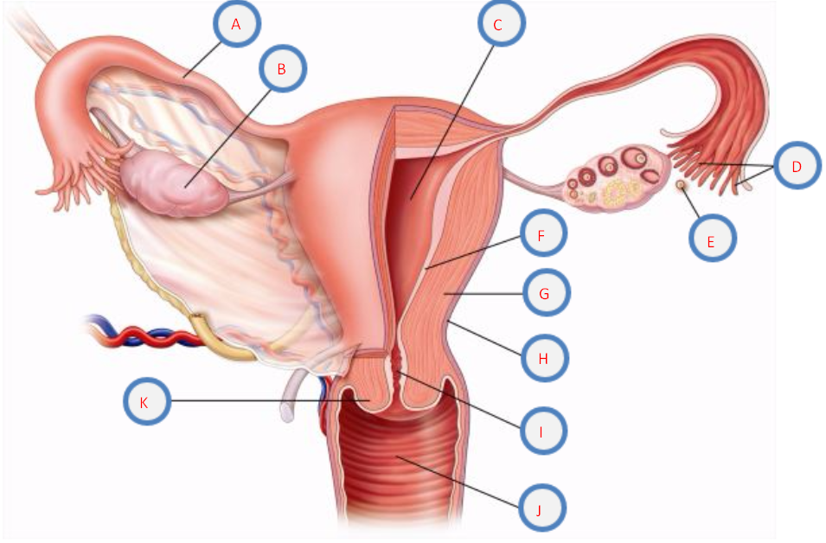
31. Use the following word bank to match the correct body cavity with the corresponding letter above.
Word Bank:
_____ ovary | _____ fimbriae | _____ uterine tube | _____ endometrium
_____ lumen | _____ cervical canal | _____ myometrium | _____ vagina
_____ perimetrium | _____ oocyte | _____ cervix

Matching (worth 9 points, 1 point each)
32. Match the terms in Column I with the descriptions in Column II.

Column I Column II

kidney stones a. inability to become pregnant
urinary tract infection b. bacterial infection that can damage the endometrium
dialysis c. viral infection that causes blisters or sores
infertility d. HPV has been linked as a cause
gonorrhea e. crystallized forms found in the urine
prostate cancer f. can lead to infertility or ectopic pregnancy
cervical cancer g. filtering the blood of wastes using technology
chlamydia h. second most common form of cancer in men
genital herpes i. bacterial infection of the urethra

Essays (worth 20 points, 10 points each)
33. Compare and contrast the symptoms and causes of diabetes mellitus and diabetes insipidus.
____________________________________________________________________________________________________________________________________________________________________________________________________________________________________________________________________________________________________________________________________________________________________________________________________________________________________________________________________________________________________________________________________________________________________________________________________________________________________________________________________________________________________________________________________________________________________________________________________________________________________________________________________________________________________________________________________________________________________________________________________________________________________________________________________________________________________________________________________________________________________________________________________________________________________________________________________________________________________________________________________________________________________________________________________________________________________________________________________________________________________________________________________________________________________________________________________________________________________________________________________________________________________________________________________________________________________________________________________________________________________________________________________________________________________________________________________________________________________________________________________________________________________________________________________________________________________________________________________________________________________________________________________________________________________________________________________________________________________________________________________________________________

34. Outline the formation of sperm in the male reproduction system and then trace the pathway that sperm takes as it leaves the male, enters the female and ultimately fertilizes the egg. Be sure to include the organs and structures the sperm passes through, how it penetrates the egg and how fertilization is completed.
____________________________________________________________________________________________________________________________________________________________________________________________________________________________________________________________________________________________________________________________________________________________________________________________________________________________________________________________________________________________________________________________________________________________________________________________________________________________________________________________________________________________________________________________________________________________________________________________________________________________________________________________________________________________________________________________________________________________________________________________________________________________________________________________________________________________________________________________________________________________________________________________________________________________________________________________________________________________________________________________________________________________________________________________________________________________________________________________________________________________________________________________________________________________________________________________________________________________________________________________________________________________________________________________________________________________________________________________________________________________________________________________________________________________________________________________________________________________________________________________________________________________________________________________________________________________________________________________________________________________________________________________________________________________________________________________________________________________________________________________________________________________

